Assignment 4 Wokwi Assignment

| Date | 05-11-2022 |
| --- | --- |
| Student name | Vishnu Priya |
| Team ID | PNT2022TMID14838 |
| Maximum Marks | 2 Marks |

**Assignment Question:**

Write code and connections in wokwi for ultrasonic sensor.

Whenever distance is less than 100 cms send "alert" to ibm cloud and display in device recent events.

Wokwi link : https://wokwi.com/projects/347473999736865364

#include <WiFi.h>//library for wifi

#include <PubSubClient.h>//library for MQtt

#define ECHO_GPIO 12

#define TRIGGER_GPIO 13

#define MAX_DISTANCE_CM 100 // Maximum of 5 meters #include "Ultrasonic.h"

Ultrasonic ultrasonic(13, 12); int distance;

void callback(char* subscribetopic, byte* payload, unsigned int payloadLength);

//-------credentials of IBM Accounts------

#define ORG "kizp10"//IBM ORGANITION ID

#define DEVICE_TYPE "IOTdevice"//Device type mentioned in ibm watson IOT Platform #define DEVICE_ID "1234567890"//Device ID mentioned in ibm watson IOT Platform #define TOKEN "1234567890" //Token

String data3; float h, t;

//-------- Customise the above values --------

char server[] = ORG ".messaging.internetofthings.ibmcloud.com";// Server Name char publishTopic[] = "iot-2/evt/Data/fmt/json";// topic name and type of event perform and format in which data to be send

char subscribetopic[] = "iot-2/cmd/command/fmt/String";// cmd REPRESENT command type AND COMMAND IS TEST OF FORMAT STRING

char authMethod[] = "use-token-auth";// authentication method char token[] = TOKEN;

char clientId[] = "d:" ORG ":" DEVICE_TYPE ":" DEVICE_ID;//client id

//-- - - - - - --

WiFiClient wifiClient; // creating the instance for wificlient

PubSubClient client(server, 1883, callback, wifiClient); //calling the predefined client id by passing parameter like server id,portand wificredential

void setup()// configureing the ESP32

{

**Serial**.begin(115200); delay(10); **Serial**.println(); wificonnect(); mqttconnect();

}

void loop()// Recursive Function

{

distance = ultrasonic.read(CM); if (distance < 100) { **Serial**.print("Distance in CM: "); **Serial**.println(distance); PublishData(distance); delay(1000);

if (!client.loop()) { mqttconnect();

}

}

delay(1000);

}

/*.....................................retrieving to Cloud */

void PublishData(float temp) { mqttconnect();//function call for connecting to ibm

/*

creating the String in in form JSon to update the data to ibm cloud

*/

String payload = "{\"Alert Distance:\":"; payload += temp;

payload += "}";

**Serial**.print("Sending payload: ");

**Serial**.println(payload);

if (client.publish(publishTopic, (char*) payload.c_str())) {

**Serial**.println("Publish ok");// if it sucessfully upload data on the cloud then it will print publish ok in Serial monitor or else it will print publish failed

} else {

**Serial**.println("Publish failed");

}

}

void mqttconnect() {

if (!client.connected()) { **Serial**.print("Reconnecting client to "); **Serial**.println(server);

while (!!!client.connect(clientId, authMethod, token)) {

**Serial**.print("."); delay(500);

}

initManagedDevice();

**Serial**.println()

}

void wificonnect() //function defination for wificonnect

{

Serial.println(); Serial.print("Connecting to ");

WiFi.begin("Wokwi-GUEST", "", 6);//passing the wifi credentials to establish the connection

while (WiFi.status() != WL_CONNECTED) { delay(500);

Serial.print(".");

}

Serial.println(""); Serial.println("WiFi connected"); Serial.println("IP address: "); Serial.println(WiFi.localIP());

}

void initManagedDevice() {

if (client.subscribe(subscribetopic)) { Serial.println((subscribetopic)); Serial.println("subscribe to cmd OK");

} else {

Serial.println("subscribe to cmd FAILED");

}

}

void callback(char* subscribetopic, byte* payload, unsigned int payloadLength)

{

**Serial**.print("callback invoked for topic: ");

**Serial**.println(subscribetopic);

for (int i = 0; i < payloadLength; i++) {

//Serial.print((char)payload[i]); data3 += (char)payload[i];

}

**Serial**.println("data: " + data3); if (data3 == "lighton")

{

**Serial**.println(data3)

else

{

**Serial**.println(data3);

}

data3 = "";

}

When the distance is less than 100cm the alert is not sent to the IBM cloud

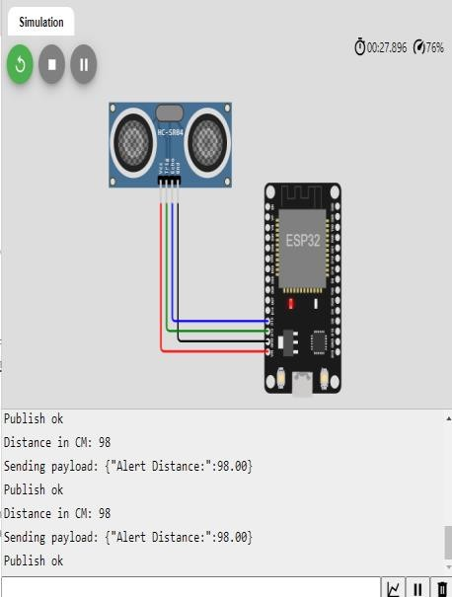

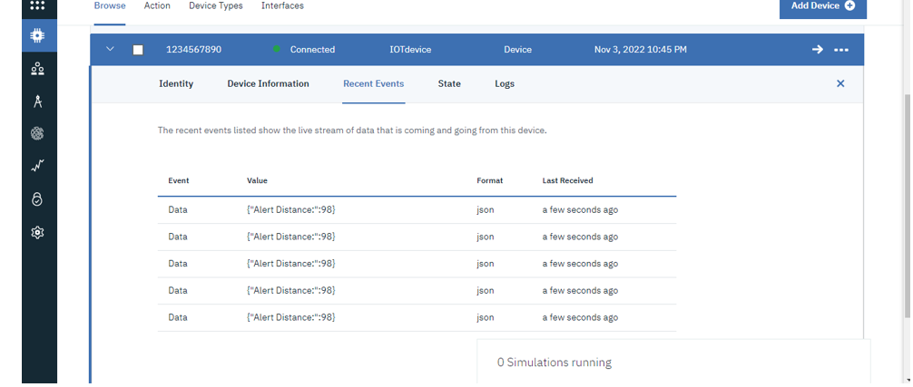

When the distance is more than 100cm the alert is not sent to the IBM cloud

